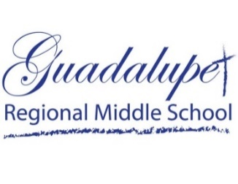

GRMS Entrance Exam

Saturday Options

Available.

April 22, 2023

May 20, 2023

June 17, 2023

\*\*\*\*\*\*\*\*\*\*\*\*\*\*\*\*\*\*\*\*\*\*\*\*\*\*\*\*\*\*\*\*\*\*\*\*\*\*\*\*\*\*\*\*\*\*\*\*\*\*\*\*\*\*\*\*\*\*\*\*\*\*\*\*\*\*\*\*\*\*\*\*\*\*\*\*\*\*\*\*\*\*\*\*\*\*

students are required to take the next exam on the schedule after turning in their applICATION to the school office.

admission is not final until an acceptance letter is sent by school and a home visit is conducted.